**UI Generation Modules**

UI is generated with the help of custom card generating functions that we have created. Each card is composed of header, body and footer and a optional more info for displaying additional content to the right of the card. Each module can be build by providing the correct parameters to the header, body and more info of the card generating function.

**Create Card Function** –

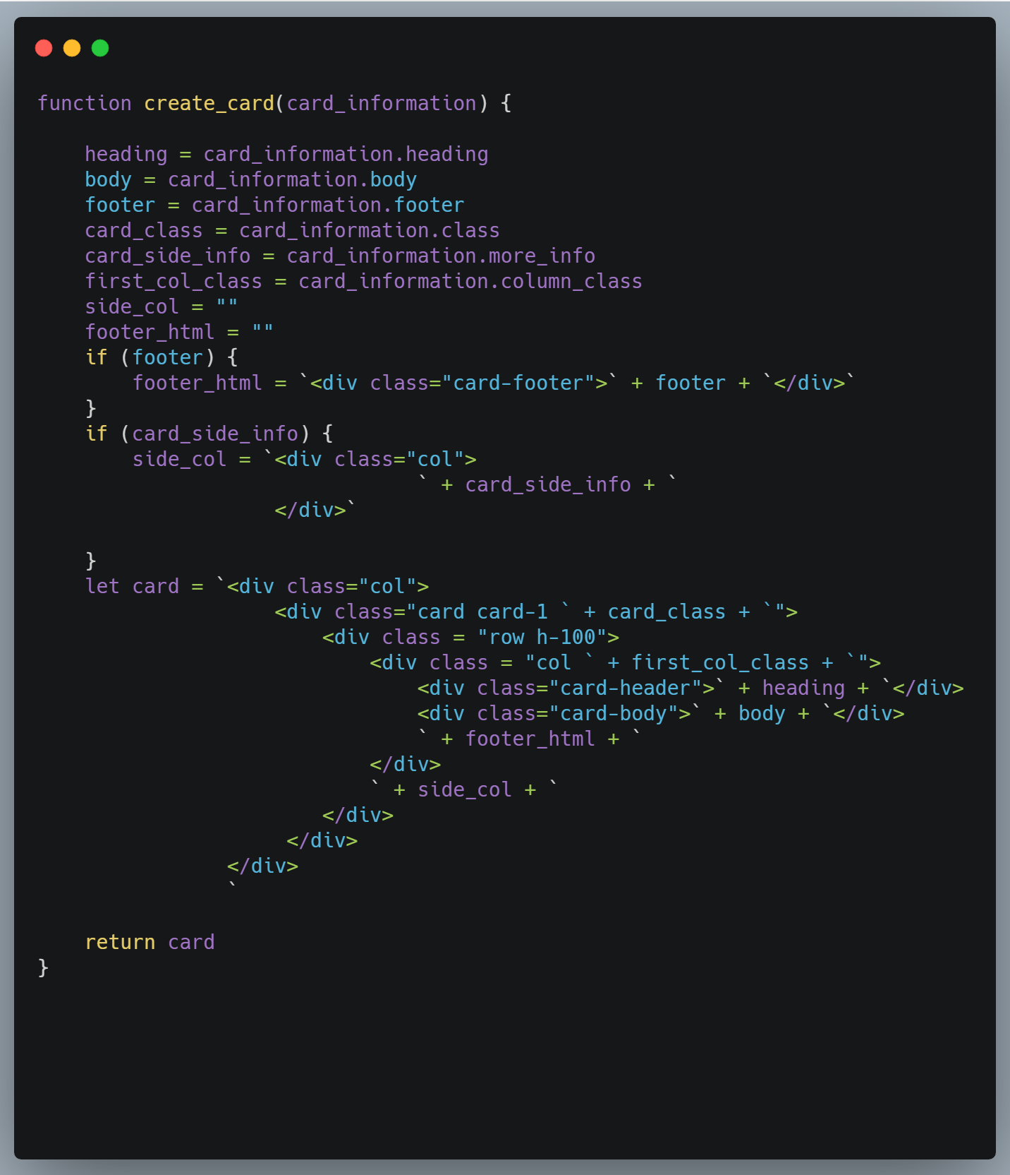

**Create Card Row –** Creates row of cards

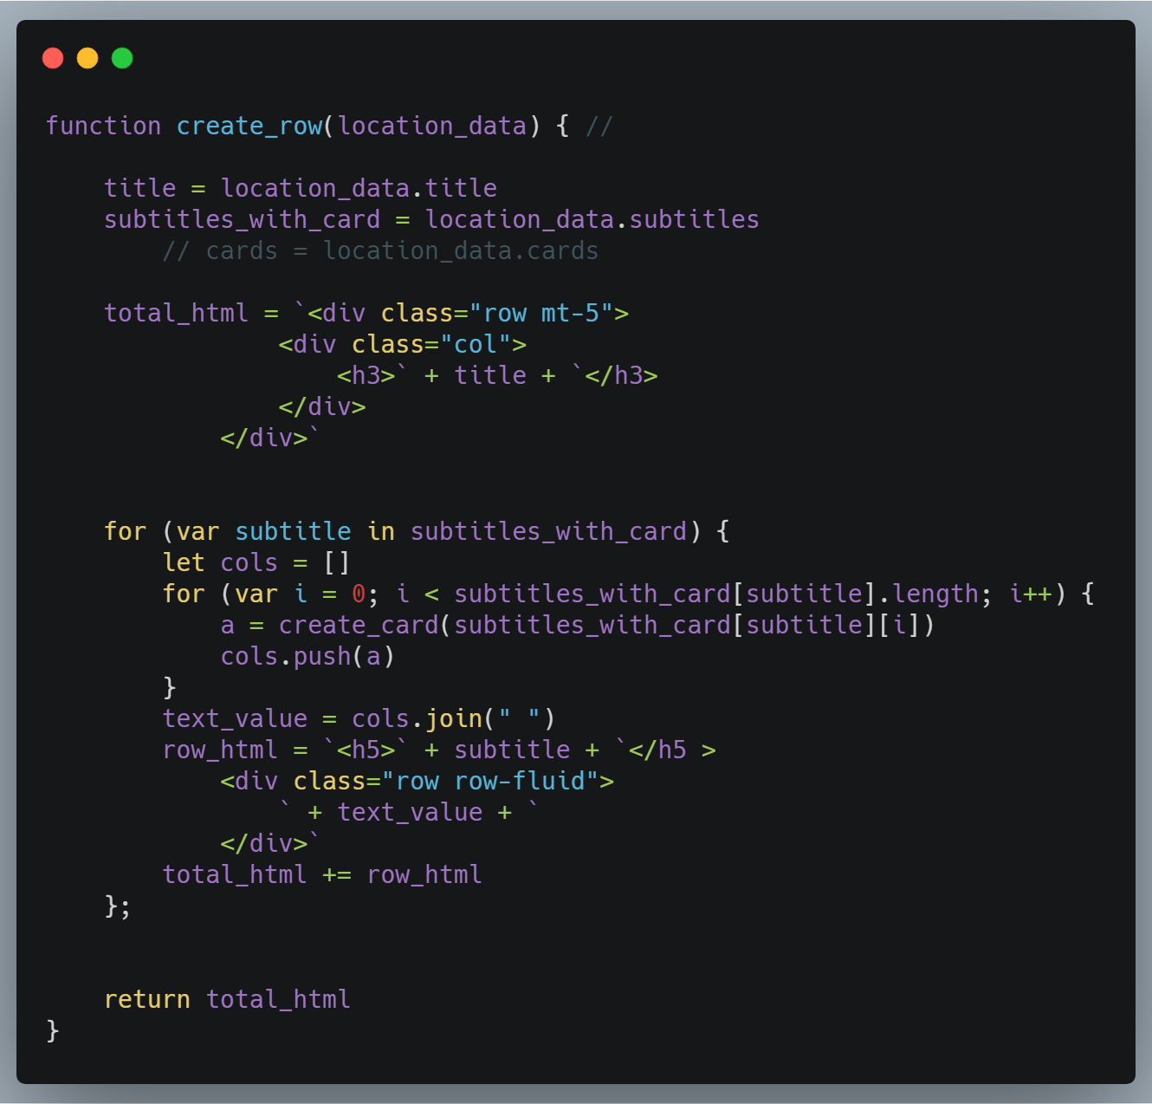

**Create Card Container** – creates multiple rows

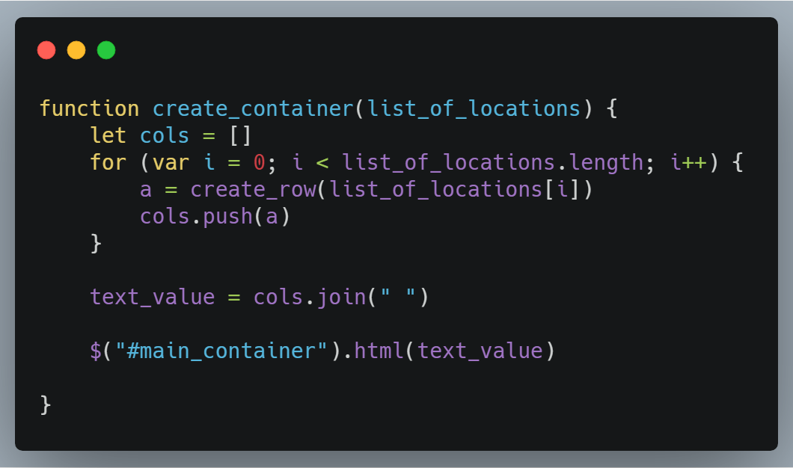

**Modules**

**Graph Module**  –

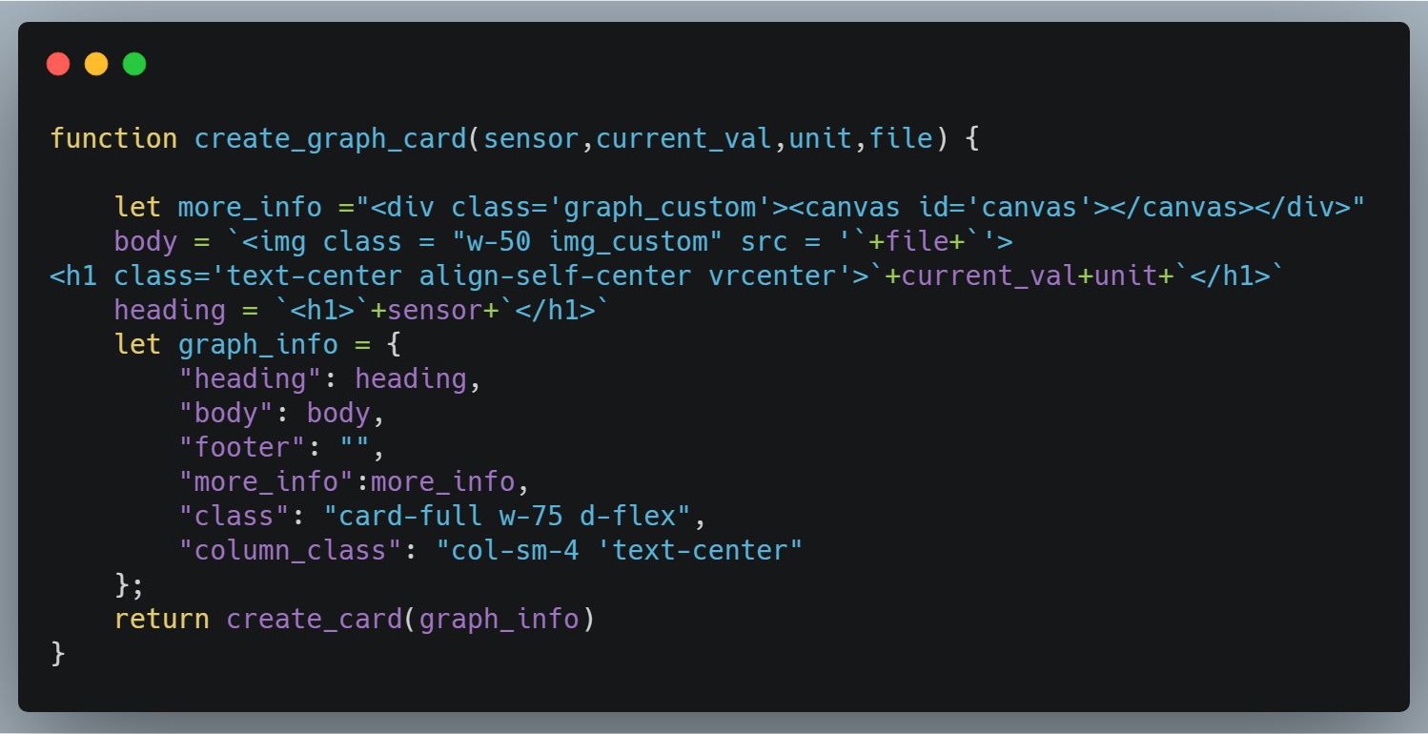

**Servo Module**  – Can be extended for any actuator control

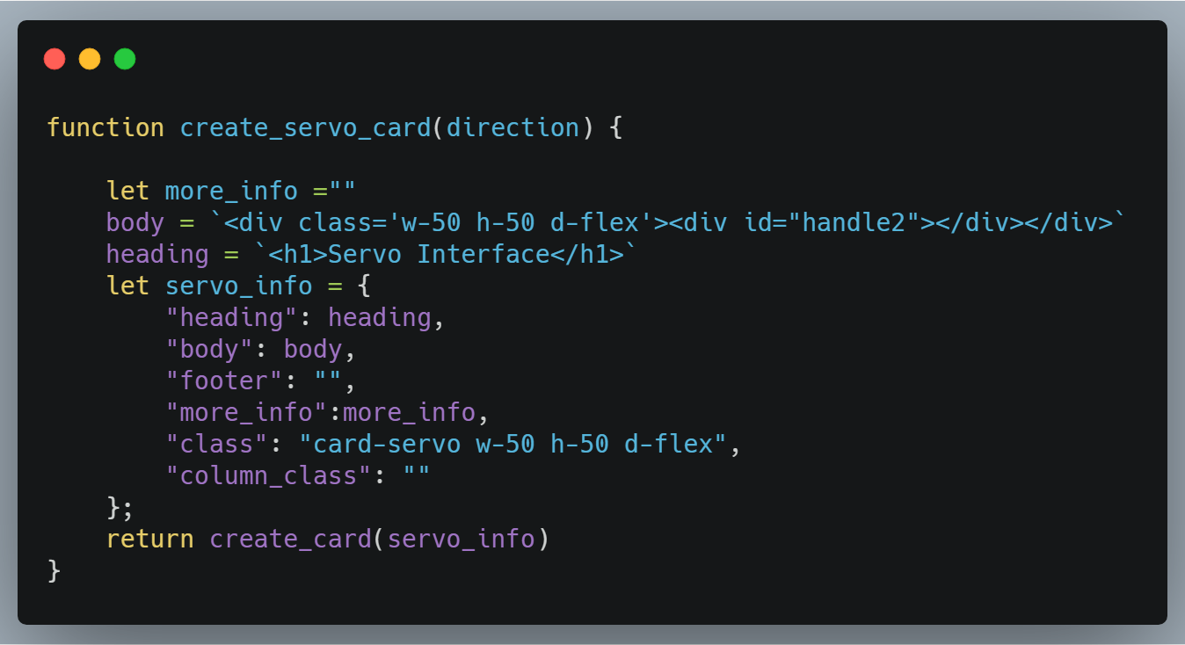

**Video Module**  –

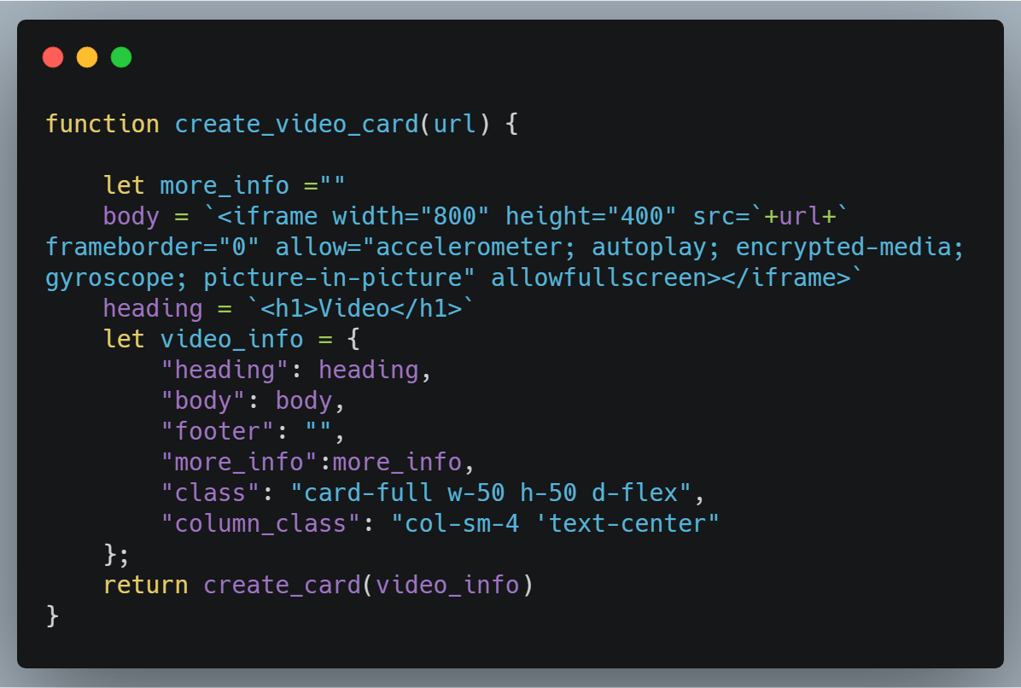

**CLI Module –**

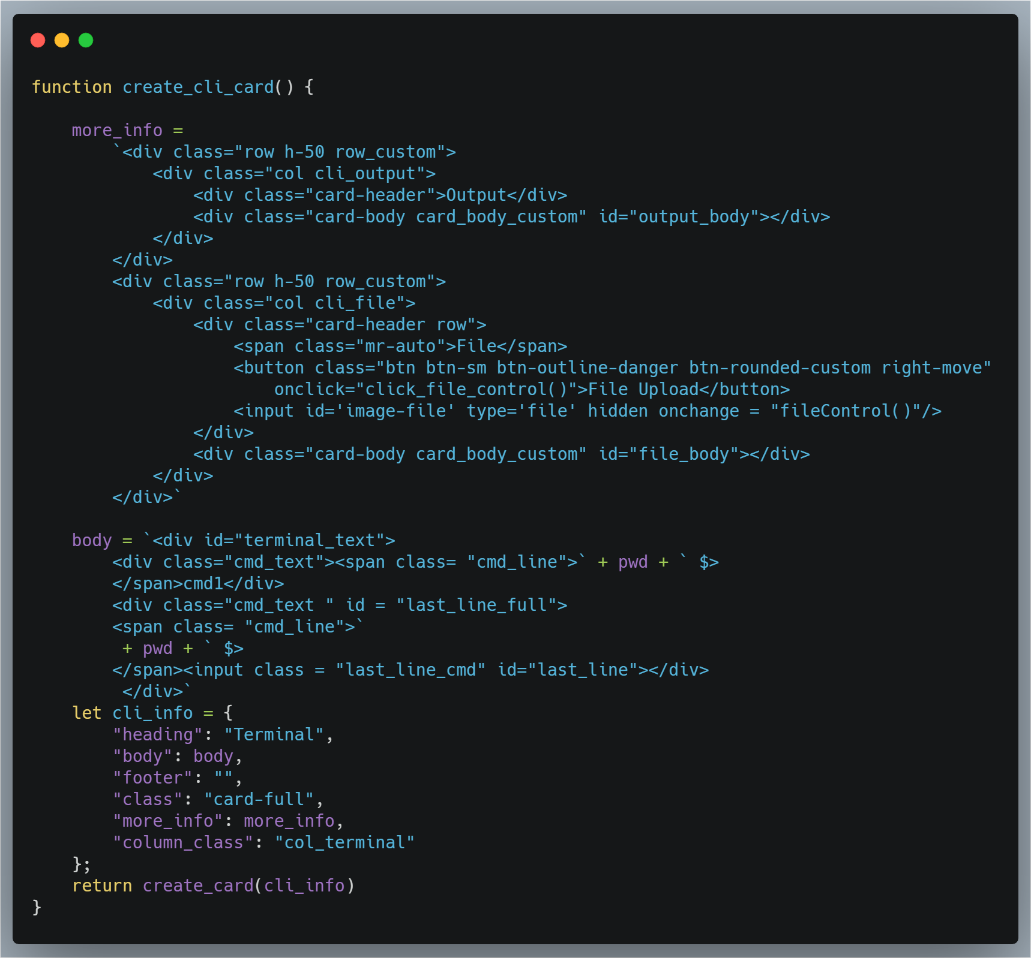

**Animations –**

